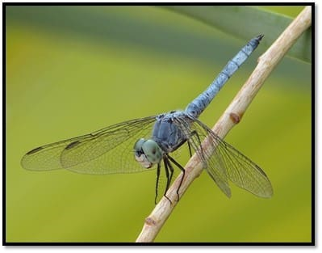
https://wetlandsparkfriends.org/wp-content/uploads/2026/06/Blue-Dasher-azdragonfly.org_.jpg

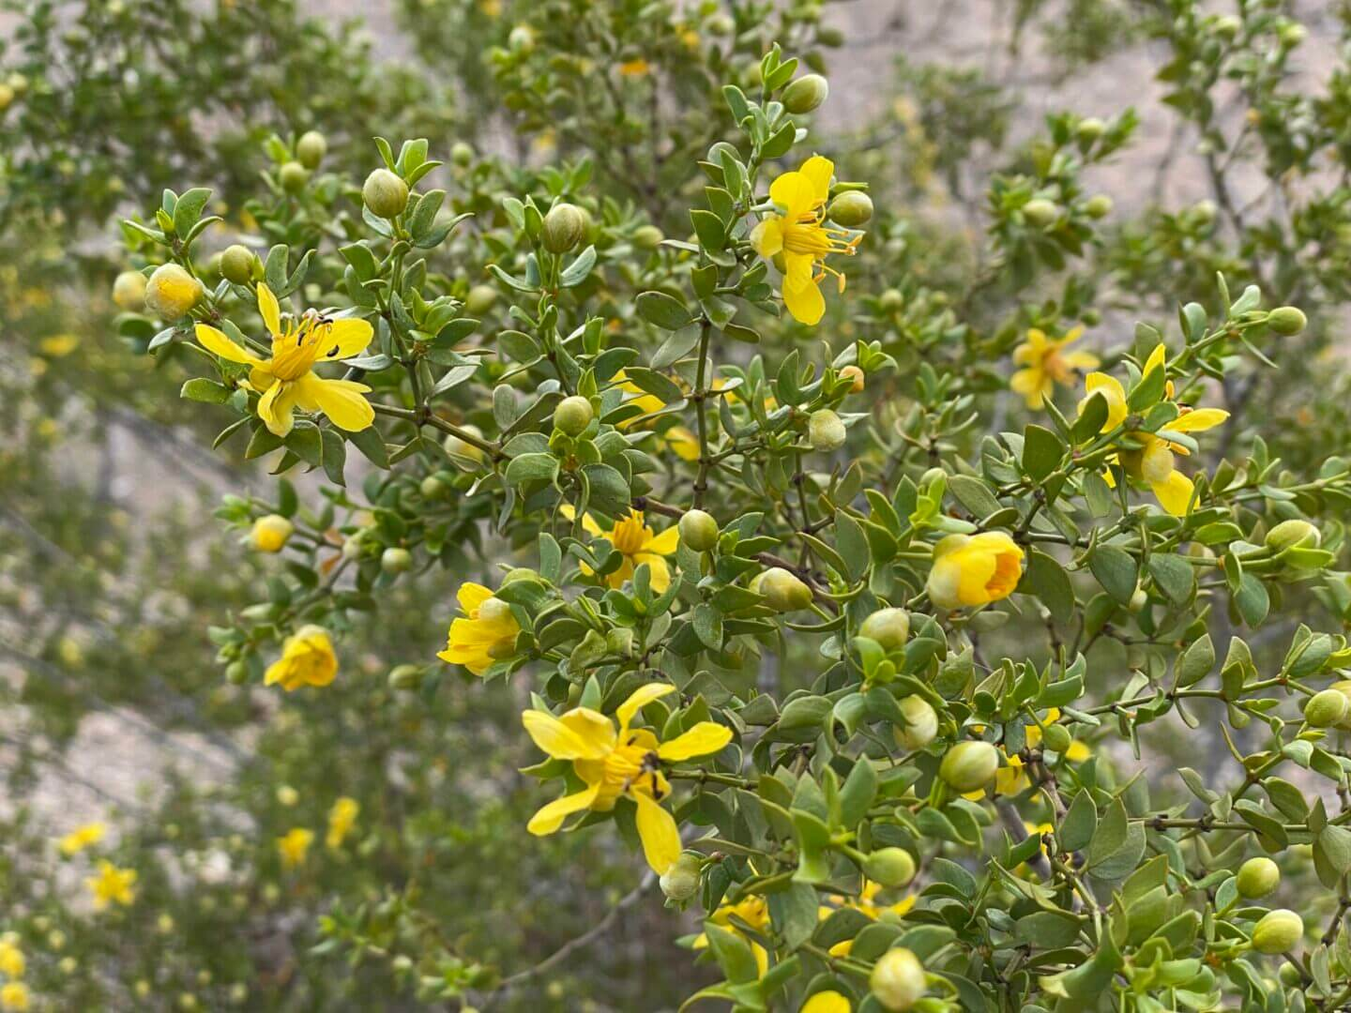
https://wetlandsparkfriends.org/wp-content/uploads/2026/04/IMG_1510-Creosote-Flower-NShore-WPF-archive-scaled.jpg
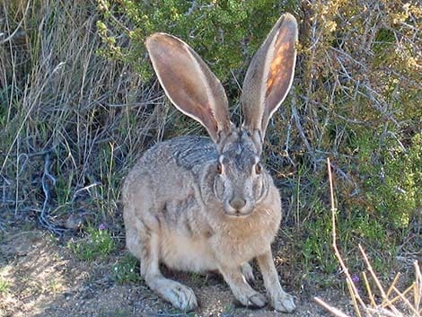https://wetlandsparkfriends.org/wp-content/uploads/2026/02/jackrabbit.jpg

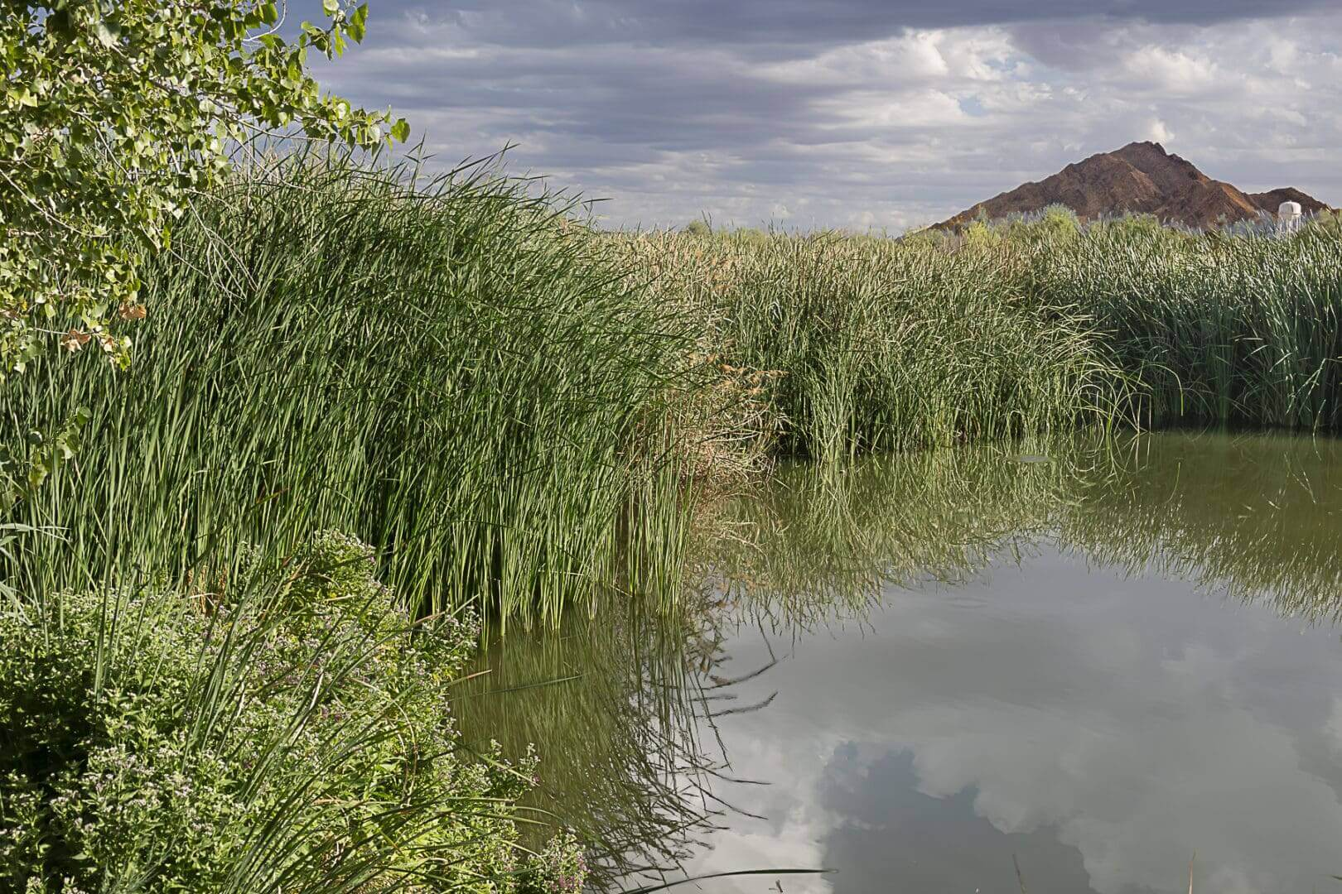
Photo credit: Clayton Fox https://wetlandsparkfriends.org/wp-content/uploads/2025/10/Quite-Pond-Clayton-Fox.jpg

